- Computer Science-
- Java Crash Course -
- 2627 -



Introduction:
- We will use Java in A Level Computer Science because it makes learning Object-Oriented Programming easier than Python. If you did not learn programming thoroughly at GCSE, please use the GCSE Paper 2 Knowledge Organiser to catch up over the summer.
- If you are using AI to support your learning, make sure you include the following at the beginning of your prompt:
“Act as an OCR A Level Computer Science expert. Teach me (a new Year 12 A Level student) this question: … ”
- For all the programming questions below, write OCR PsuedoCode on the booklet and create the Java Program on CodeHS
Predict what each of the Java expressions below evaluate to, then code them to find out whether you were correct.
 | Code | My prediction | Actual output  Why?
1 | int x = 5  int y = 10  int z = ++x * y—-  System.out.println(“z=” + z)
2 | System.out.println("1 + 2 = " + 1 + 2);  System.out.println("1 + 2 = " + (1 + 2));
3 | System.out.println(1 + 2 + "abc");  System.out.println("abc" + 1 + 2);
4 | x=1  System.out.println(x++ + ++x)
5 | x=1  System.out.println(x++ * ++x)

6 A description of temperature conversion could be:
To convert from Celsius to Fahrenheit, first multiply by 180/100, then add 32
To convert from Fahrenheit to Celsius, first subtract 32, then multiply by 100/180
Write a program that where the expressions to calculate the above use as few parentheses as possible.

7 The formula below calculates the instantaneous velocity (velocity at a particular instant) of a falling object:
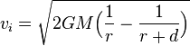
Instantaneous velocity of a falling object that has travelled distance on a planet with mass and radius where G is the gravitational constant.
The constants for Earth are
- M=5.97x10²⁴
- r = 6378000
- G = 6.67x10⁻¹¹

Write a program that codes the expression above in a single statement, using as few parentheses as possible.
Use it to calculate the terminal velocity of a peregrine falcon by inputting the following value for d: 413.3736535 metres.

Selection – If statements
Pseudocode keywords:
IF…THEN ENDIF INPUT OUTPUT INTEGER REAL
Program Spec | Pseudocode
An airline charges £7.50 per kilogram for cargo. If the package/carton is over 20kg, a surcharge of £10.25 is applied. Write a program that:
- allows the user to input the weight
- Calculates the weight per kilogram
- Adds the surcharge if necessary
- Outputs the cost
Another airline charges £2.50 per kilogram if the package is under 20kg, or £3.50 per kilogram if 20kg or over. Write an algorithm that:
- allows the user to input the weight
- Calculates the weight per kilogram
- Outputs the cost
A youth centre has three rooms for different age groups. If the child is under 10 they go into room 1, under 14 then room 2, and under 18 then room 3. Write an algorithm that:
- Allows the user to enter the age
- Outputs the correct room

Create a flow chart diagram for the youth centre program:

Program Spec | Pseudocode
The authorities want to change the fines for speeding. Create a program that will:
- Output the options below:
- 10mph above limit
- 20mph above limit
- 30 mph and above limit
- 5mph above limit in an urban zone
- Allow the user to enter their chosen option
- Output the relevant penalty
- 3 points on licence
- 3 points on licence and £250 fine
- 6 points on licence and £1000 fine
- Licence revoked for 5 years

Draw a flow chart diagram showing the flow of the two programs below

Program 1:
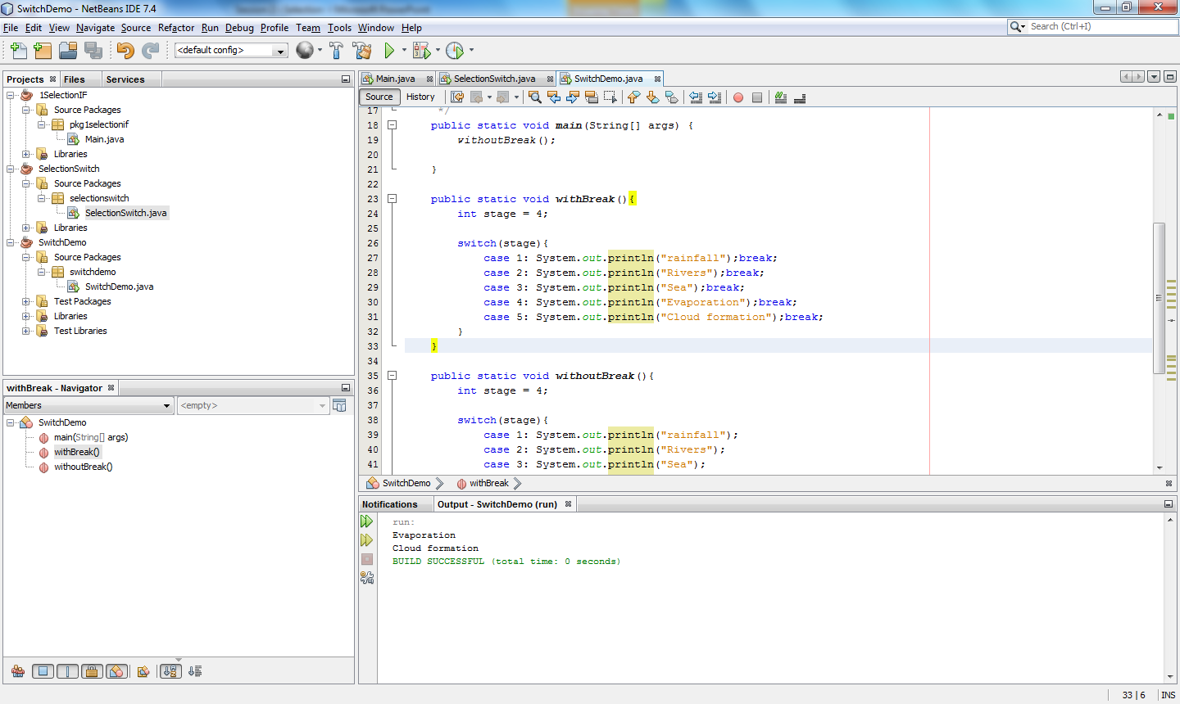

Select Case
Pseudocode keywords:
SELECT CASE INPUT OUTPUT INTEGER REAL
Program Spec | Pseudocode
A school is taking students on three trips on the same day. Create a program that will:
- Let the user enter their selected option from:
- DofE
- France
- Bletchley Park
- Output the following advice:
- I feel sorry for your feet
- Ou est l’autobus?
- Bring a packed lunch
Use fall-through in a program that will allow the user to enter an integer that represents the day of the week. It must then output the days remaining this week. You can use the default case to handle integers out of the acceptable range.
e.g. Input: 4
Output:
Friday
Saturday
Sunday

Program Spec | Pseudocode
A website wants to create a PC advisor. They would like to ask the user where they are up to with their PC- build and then give them a list of instructions.
- Let the user enter the selected option from:
- Just opened the case
- Seated the motherboard
- Seated the CPU
- Output a list of appropriate instructions from:
- Seat the motherboard
- Seat the CPU
- Add heatsink gel and seat the heatsink
- It must by default remind all users: “Remember to wear an anti-static wrist strap.”

e.g. by inputting b the program will output:
Seat the CPU
Add heatsink gel and seat the heatsink
Remember to wear an anti-static wrist strap.
The government want to change the fines for speeding. Create a program that will:
- Output the options below:
- 10mph above limit
- 20mph above limit
- 30 mph and above limit
- 5mph above limit in an urban zone
- 10mph and above limit in an urban zone
- Allow the user to enter their chosen option
- Output the relevant penalty
- 3 points on licence
- 3 points on licence and £250 fine
- 6 points on licence and £1000 fine
- Licence revoked for 5 years
- Licence revoked for 5 years and a £1000 fine.
Use fall through to make your program as efficient as possible.

Boolean operators
Code the following problems on CodeHS. For question 2 onwards, amend your data appropriately to test of the conditions work.

1 | INTEGER numSpots = 2  STRING colour = “Red”  IF numSpots == 2 AND colour == “red” THEN  OUTPUT “two spot ladybird”  ENDIF
2 | IF numSpots == 22 OR numSpots==14 THEN  OUTPUT “Yellow, 14-spot or 22-spot ladybird”  ENDIF
3 | IF numSpots == 18 and NOT colour== “brown” THEN  OUTPUT “Cream-spot ladybird”  ENDIF
4 | IF numSpots == 2 OR numSpots == 4 AND NOT color==”black” THEN  OUTPUT “Harlequin ladybird”  ENDIF

Selection notes
What is a branch?

What is selection?

What is the difference between an IF and a Select/Case?

Name three common Boolean operators:

Pseudocode | Java

Spot the mistakes and write the correct line of code below:

if numspots = 3 || 5{
//program logic here
}

Iteration
Create a new project called Iteration. Try the program below, running each section as it asks you.
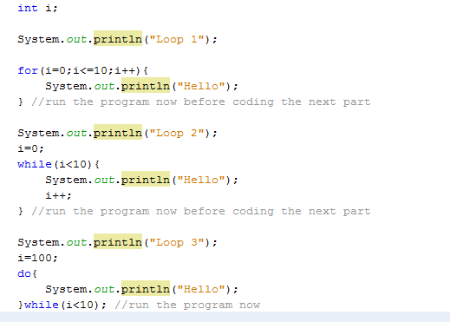

 | Loop1 | Loop 2 | Loop 2
Correct name
Used when:
Diagram

Iteration practice (Write the PsuedoCode below and Program it on CodeHS)
- The optimum ratio of male to female sheep in animal husbandry is 1:20. A farmer has 100 sheep. Create a program that outputs a list of sheep in female:male order.

- There are a number of entrants in a sheep shearing contest. Each entrant is required to type their name in to register. The program greets each entrant with a “Howdy!” until someone enters “quit”.

- Re-write program two so it uses the opposite type of condition (i.e. pre post or vice-versa)

.

Trace Table (OCR GCSE 2023 Practice Paper 2)
OCR Drones flies goods around the country using drones.
A pilot code is automatically generated when a new pilot joins the company.
This algorithm generates a code for each pilot:
01 a = input("Enter first letter of first name")
02 b = input("Enter first letter of second name")
03 c = random(1,100)
04 while c < 100
05 c = c * 10
06 endwhile
07 pilotCode = a + b + str(c)
08 print(pilotCode)
Complete the trace table for the given algorithm.
Lines 01 to 03 have already been completed.
You may not need to use all rows in the trace table.

Line number | a | b | c | pilotCode | Output
01 | H
02 |  | K
03 |  |  | 9

Java Methods
Subroutines are known as methods in Java. For the duration of year 12 we will call them procedures and functions.
Example procedure:
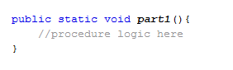
To call this procedure in my main program I need to simply type the procedure name e.g. part1();
Example function:

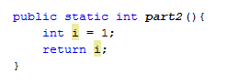

To call this function from my main program I need to do something with the return value in my main program. An example of this could be:

int x;
x = part2();

Practice questions
A lamb generates approximately 2.1kg CO₂/kg. A sheep generates approximately 13.6kg CO₂/kg.
Create a Java program on CodeHS that allows the user to enter whether they own a lamb or a sheep and its weight, and output the carbon footprint of the livestock. Use functions and procedures appropriately along with the pseudocode hints below.

main()
print(“Welcome to the livestock carbon footprint calculator”)
animalType = getAnimal()
calculateFootprint(animalType)
end

Function getAnimal()
print(“Enter animal type: Sheep or Lamb”)
animal = input()
return animal
end function

Procedure calculateFootprint( STRING animalType)
REAL result
{comment: (Perform relevant calculation for carbon footprint)}
print(result)
end procedure

