1.3.2 Wired and Wireless Network Protocol
1. The owners of a large bakery have a Local Area Network (LAN) with a star topology. They order their supplies over the Internet. When data is transmitted from the bakery to the supplier, network protocols are used.
Define what is meant by a ‘network protocol’.

[1]

2. The owners of a large bakery have a Local Area Network (LAN) with a star topology. They order their supplies over the Internet. When data is transmitted from the bakery to the supplier, network protocols are used.
Define what is meant by a ‘network protocol’.

[1]

3. Ethernet is considered a standard.
Explain why Ethernet is a standard.

[2]

4(a). Explain the difference between how the IMAP (Internet message access protocol) and SMTP (simple mail transfer protocol) protocols are used.

[2]

(b). When connecting computers into a network, the use of appropriate protocols are important.
Explain what is meant by a protocol.

[2]

5. A library does not use encryption when data is transmitted through its network.
Give two reasons why the library should use encryption.
1
2

[2]

6. Naomi’s office has five computers connected into a Local Area Network (LAN). There is also one printer that all the devices can print to.
The LAN is set up as a mesh topology.
Draw connections to show one way that the devices could be connected using a mesh topology.
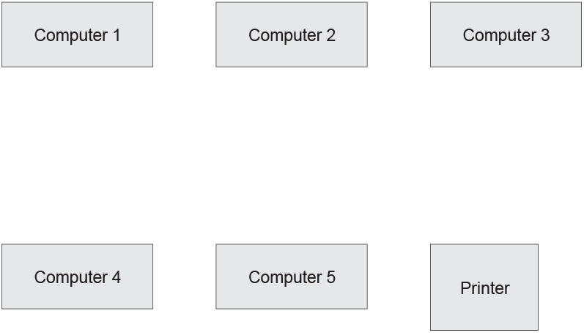

[2]

7. Describe the star topology. You may use a diagram.

[2]

8. The building is considering the implementation of a virtual network.
Describe what is meant by a virtual network.

[2]

9. Protocols are used to transmit data through the network and over the internet.
Identify one protocol that can be used to perform each of the following tasks: [2]

Send an email
Access a website securely

10. The owners of a large bakery have a Local Area Network (LAN) with a star topology. They order their supplies over the Internet. When data is transmitted from the bakery to the supplier, network protocols are used.
TCP/IP is a set of protocols based on layers.
- With regards to network protocols, define what is meant by a ‘layer’.[1]

- Describe one advantage of using layers to construct network protocols.[2]

11. TCP/IP is a set of protocols based on layers.
- With regards to network protocols, define what is meant by a ‘layer’.[1]

- Describe one advantage of using layers to construct network protocols.[2]

12. A university has buildings in two sites that are 5 miles apart.
Data transmitted over the network uses different protocols.
Tick one box in each row to identify whether the protocol is related to email, transferring files or accessing websites.

Protocol | Email | Transferring files | Accessing websites
POP
FTP
SMTP
HTTPS

[4]

13. Naomi’s office has five computers connected into a Local Area Network (LAN). There is also one printer that all the devices can print to.
Ethernet cables are used within the office building.
Tick one box in each row to identify if the statement about Ethernet is True or False.

Statement | True | False
Ethernet is a protocol
Ethernet uses wireless data transmission
Ethernet can transmit data at speeds of up to 100 Gbits per second
Ethernet is a protocol within the TCP/ IP stack

[4]
14. A bank uses a local area network to connect all the computers in its head office.
Computers in the network can be identified using both IP addresses and MAC addresses.
Describe two differences between IP addresses and MAC addresses.

[4]

15. For each of the scenarios below, identify the most appropriate protocol to be used and explain the function of the protocol.
- A user wants to transfer a file directly from his computer to his friend’s computer.

[2]
- A customer wants to securely log into her bank’s website to check her account balance.

[2]

16. An office has a LAN (Local Area Network). The office has four employees who each have a laptop. The office also has one server and one networked printer.
The office is set up as a star network with a switch at the centre. All devices are connected to the network using cables.
- Draw the devices and connections in the office star network. All devices must be clearly labelled.
[3]
- Describe the role of the switch in the office network.

[2]

17. The IP address 192.149.119.226 is linked to the website with a URL of https:/www.ocr.org.uk
When https:/www.ocr.org.uk is entered into a browser, the website homepage is loaded.
Describe the relationship between the website URL (https:/www.ocr.org.uk), the IP address and the webserver.

[5]

18. The following table has descriptions of Ethernet and WiFi.
Tick (✓) one box in each row to identify if the description is more appropriate for Ethernet or WiFi.

 | Description | Ethernet | Wifi
 | A wired connection
 | More likely to be affected by interference
 | Data can be transmitted at a faster speed
 | Wireless transmission
 | Shorter transmission range before data is lost

[5]

19. A student is performing a range of actions on the internet using their computer.
A range of protocols are used for the transmission of data by the student’s computer, and the web servers they are accessing.
- Complete the table by identifying the most appropriate protocol for each of the tasks the student is performing.
Task | Protocol
Requesting to view a news webpage from a web server
Entering a username and password to access their bank account
Downloading a text document from a web server
Checking for new emails in their inbox

[4]
- Some protocols have layers.
Give two reasons why protocols have layers.
1
2
[2]

20. Computers access the Internet using the TCP/IP model.
- The TCP/IP model uses layers including the application layer and transport layer.
Explain why the TCP/IP model uses layers.

[2]
- TCP/IP is one example of a protocol.
Give the name of one appropriate protocol for each task in the table.
Task | Protocol for this task
Sending an email from one
mail server to another
Transmitting a file from a
client to a server
Viewing a website using a
web browser
Downloading an email to
your computer

[4]

21. The student’s computer is part of their home Local Area Network (LAN). The LAN currently only has wired connections.
- One characteristic of a LAN is that they are set up over a small geographical area.
Give one other characteristic of a LAN.

[1]
- Describe the benefits of the student changing their home LAN to include wireless connections.[4]

- State two drawbacks of changing their home LAN to include wireless connections.[2]
1
2

22. A university has buildings in two sites that are 5 miles apart.
- Explain how each of the following can contribute to the performance of a network.[4]
Wifi frequency

Interference

Number of concurrent users

Type of network traffic

- Identify one other factor that can contribute to the performance of a network.[1]

- Describe how packet switching can be used when sending data.[4]

