1.3.1 Network And Topologies
1. A law company currently use a Local Area Network (LAN) linked to a Wide Area Network (WAN).
They want to upgrade their system to utilise cloud storage.
Define what is meant by a Wide Area Network.
[1]

2. Amir has a home network that includes two laptop computers, four mobile phones, and two televisions.
Identify the type of network Amir has at home.
[1]

3. Hope has a network in her house. The main devices are shown in the diagram.
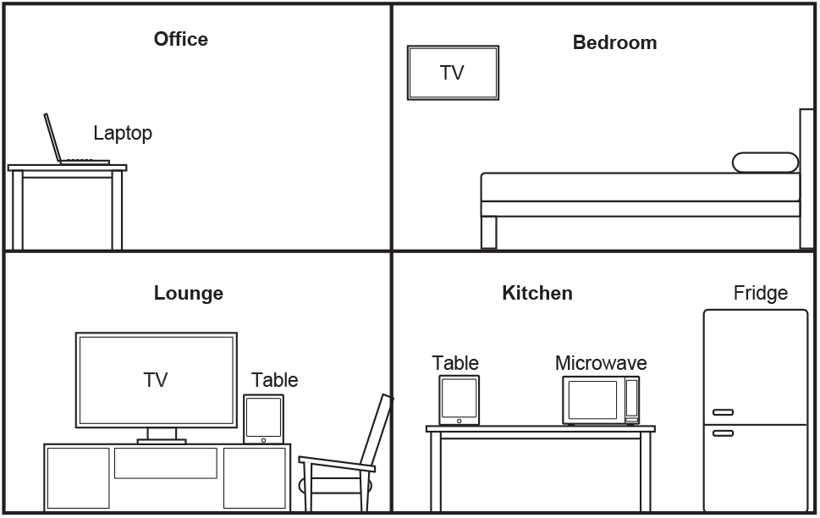
Devices on the network do not currently have Internet access.
Identify one device that Hope can use to connect her home network to the Internet.
[1]

4. A law firm currently use a Local Area Network (LAN) linked to a Wide Area Network (WAN). They want to upgrade their system to utilise cloud storage.
Define what is meant by a Wide Area Network.

[1]

5. A company, OCR Supermarkets, has supermarket stores throughout the country. The computers for each store connect to the central office using a Wide Area Network (WAN).
Identify two differences between a WAN and a LAN (Local Area Network).

Difference 1:

Difference 2:

[2]

6. Zoe is organising a LAN-party. Her friends will each bring a computer to the party so that they can play games against each other.
Describe what is meant by a Local Area Network (LAN).

[2]

7(a). A university has buildings in two sites that are 5 miles apart.
Describe the difference between a LAN and a WAN.

[2]

(b). A university has buildings in two sites that are 5 miles apart.
Site A has 4 classrooms. Site B has 2 classrooms. The network on each site between the classrooms is a star topology using a switch. The two sites are connected over the Internet.
Complete the network diagram for site A of the University.
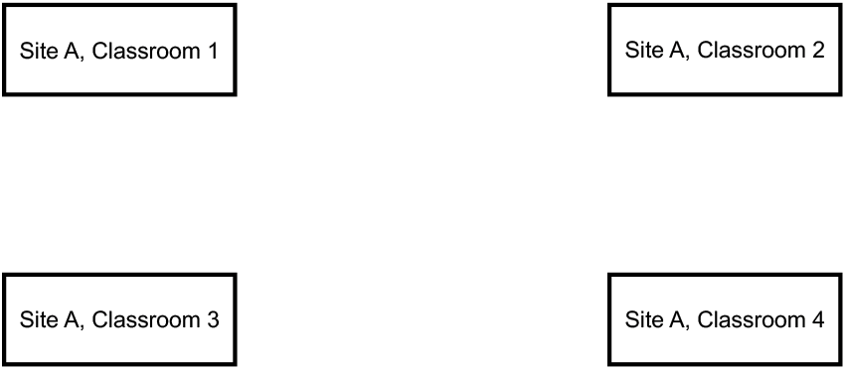

[2]

8. A bank uses a local area network to connect all the computers in its head office.
State two ways the local area network can be used to monitor the work of employees.
1

2

[2]

9. The owners of a large bakery have a Local Area Network (LAN) with a star topology. They order their supplies over the Internet. When data is transmitted from the bakery to the supplier, network protocols are used.
Give two reasons why the bakery may use a star network topology for their LAN.

1
2

[2]

10. A school has all of its computers in a local area network (LAN).
State two benefits of a LAN.
1

2

[2]

11(a). Hope has a network in her house. The main devices are shown in the diagram.
Explain why Hope’s network uses a peer-to-peer model and not a client-server model.

[3]

(b). State whether Hope’s network is a LAN or a WAN. Justify your choice.

Choice

Justification

[3]

12. Computer 1 enters the URL www.ocr.org.uk into a web browser. This is then converted into the IP address of the webserver that hosts the website.
Explain how the URL www.ocr.org.uk is converted into the IP address.

[3]

13. A house has computers in each room and a central router. Every room allows both Ethernet and WiFi connections to the router.
Identify if the house network is a LAN (local area network) or a WAN (wide area network).
Justify your choice.

Network type:

Justification:

[3]

14. A network has several routers.
identify three tasks carried out by a router.

1
2
3

[3]

15. A law company currently use a Local Area Network (LAN) linked to a Wide Area Network (WAN).
They want to upgrade their system to utilise cloud storage.
Explain two disadvantages to the law company of storing their data in the Cloud.

1
2

[4]

16. A law firm currently use a Local Area Network (LAN) linked to a Wide Area Network (WAN). They want to upgrade their system to utilise cloud storage.
Explain two advantages to the law firm of storing their data in the cloud.

[4]

17. Hope has a network in her house. The main devices are shown in the diagram.
The network has one wireless access point in the kitchen that transmits data on the 5 GHz frequency.
- When the laptop is in the kitchen, it has better network performance.
Explain why the laptop’s network performance is lower in the bedroom.

[2]
- State two ways Hope could improve the wireless network performance in the bedroom.

1
2
[2]

18. A law firm currently use a Local Area Network (LAN) linked to a Wide Area Network (WAN). They want to upgrade their system to utilise cloud storage.
Explain two disadvantages to the law firm of storing their data in the cloud.

[4]

19. The owners of a large bakery have a Local Area Network (LAN) with a star topology. They order their supplies over the Internet. When data is transmitted from the bakery to the supplier, network protocols are used.
The owners of a large bakery have a Local Area Network (LAN) with a star topology.
Explain four reasons why the bakery may use a star network topology for their LAN.

[4]

20. A house has computers in each room and a central router. Every room allows both Ethernet and WiFi connections to the router.
- Describe the purpose of the router in the house’s network.

[2]
- Identify two additional items of network hardware, apart from cables and a router, that may be used within the house network.

1
2

[2]

21. A library has a LAN (Local Area Network).
A LAN allows access by both wired and wireless devices.
Users have reported that the network sometimes runs very slowly.
- Explain why the number of devices using the network at the same time can affect the performance of the network.

[3]
- Identify one other factor that can affect the performance of the network.

[1]

22. A law company currently use a Local Area Network (LAN) linked to a Wide Area Network (WAN).
They want to upgrade their system to utilise cloud storage.
Explain two advantages to the law company of storing their data in the Cloud.

1
2

[4]

23. An office has a LAN (Local Area Network). The office has four employees who each have a laptop. The office also has one server and one networked printer.
The office introduces a WAP (Wireless Access Point) to allow network access to wireless devices.
The office manager has noticed that the performance of the network has recently decreased.
- Describe how introducing wireless access could have slowed down the network.

[2]
- Identify two other factors that can affect the performance of a network.

1
2

[2]

24. A company, OCR Supermarkets, has supermarket stores throughout the country. The computers for each store connect to the central office using a Wide Area Network (WAN).
OCR Supermarkets use a client-server network to connect the checkout computers to the store's server.
Describe two benefits to OCR Supermarkets of using a client-server network instead of a peer-to-peer network.

Benefit 1:

Benefit 2:

[4]

25. An office has a LAN (Local Area Network). The office has four employees who each have a laptop. The office also has one server and one networked printer.
The office is set up as a star network with a switch at the centre. All devices are connected to the network using cables.
- Draw the devices and connections in the office star network. All devices must be clearly labelled.
[3]
- Describe the role of the switch in the office network.

[2]

26. The IP address 192.149.119.226 is linked to the website with a URL of https:/www.ocr.org.uk
When https:/www.ocr.org.uk is entered into a browser, the website homepage is loaded.
Describe the relationship between the website URL (https:/www.ocr.org.uk), the IP address and the webserver.

[5]

27. The artist uploads images to be displayed on a website. This is a client-server relationship.
- Identify the computer that is acting as the client in this scenario and justify your choice.

Client computer

Justification
[3]

- Identify the computer that is acting as the server in this scenario and justify your choice

Server computer

Justification
[3]

28. Eve’s computer has system software including an Operating System and Utility Software.
Eve stores her computer program on the cloud whilst working on it.
- Describe the benefits to Eve of storing the program on the cloud.

[3]
- Describe the drawbacks to Eve of storing the program on the cloud.

[3]

29. A house has computers in each room and a central router. Every room allows both Ethernet and WiFi connections to the router.
A user enters a uniform resource locator (URL) into a web browser on one of the computers in the house.
A system is then used to find the IP address of the web server associated with the URL.
- Name the system which matches URLs to IP addresses on the web.

[1]
- The following statements describe what happens after the IP address has been found and returned to the user’s computer.
There are five missing statements in the table.
Write the letter of the missing statements from the table in the correct place to complete the description.

1 | The request is put into packets
2
3 | The packets are sent across the network
4
5
6 | If they have not arrived:
7 | A timeout is sent to request the packets are resent
8 | If they have arrived:
9
10

 | Letter | Statement
 | A | The server checks if all the packets have arrived
 | B | The packets are put in order
 | C | The request is processed by the web server
 | D | The packets are received by the host server
 | E | Each packet is given the address and a number

[5]

30. Hope has a network in her house. The main devices are shown in the diagram.
Some of Hope’s files are stored on the cloud.
Describe the benefits and drawbacks to Hope of storing her files on the cloud.
Benefits

Drawbacks

[6]

31. Users can access websites from library computers.
Complete the description of accessing websites using the given list of terms. Not all terms will be used.
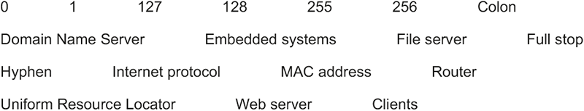
A website is hosted on a ..................................................................... .The computers that access the websites are called ..................................................................... .
The user enters the .................................................................... into a web browser, The web browser sends a request to the ..................................................................... for the matching IP (Internet Protocol) address, If found the IP address is returned. A request is then sent to this IP address.
An IPv4 address is made of 4 groups of digits, Each group can be between the denary values ..................... and ..................... . The groups of digits are separated by a ..................................................................... .

[7]

32. A small island has 100 people living on it. The island has just been connected to the Internet, after previously having no Internet or mobile phone signal.
Discuss the impact on the island’s inhabitants and businesses of getting access to the Internet.
In your answer you might consider the impact on:
- inhabitants
- businesses
- ethical issues
- privacy issues

[8]
33. Amir has a home network that includes two laptop computers, four mobile phones, and two televisions.
The network uses a star topology with a central switch. The switch has an integrated wireless access point (WAP).
- Describe the similarities and differences between a switch and a router.
Similarities
Differences

[6]
- Draw the star topology for Amir’s home network. Clearly label each device.

[3]

