

6th Form News May 2018

We have had an eventful few weeks with our 6th form students representing the school at a range of venues from the London Business School to the Jack Petchy Awards.

It’s full steam ahead for Year 13 who are working hard to achieve the ambitious targets they have been set by their teachers. There are 99 students in Year 13; 96 students applied through UCAS for a place at university; every student has had an offer and over 50% of these offers are for Russell Group Universities. Two students have achieved places on Art Foundation courses and one student is working towards starting an apprenticeship. We congratulate them all on their success to date and wish them the best of luck going forward. Practical examinations are underway with the A level drama group giving an exceptional performance of “Inspector Calls”.

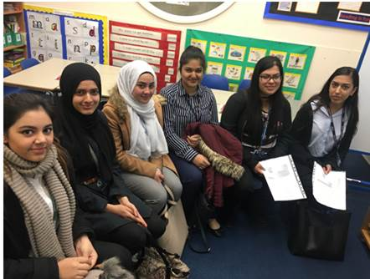Meanwhile Year 12 have been busy building UCAS profiles. Last Friday’s assembly was delivered by a representative from Unifrog who talked students through how best to create short lists of courses and universities. Students also need to be thinking about what they will include in their UCAS statement. Jane Marshall form Imperial College London will also be advising students on how to enhance their statements.

Our BTEC Health and Social Care students have got off to a great start as they will be attending Allenby school on a weekly basis supporting students who have complex learning needs.

6th Form Opportunities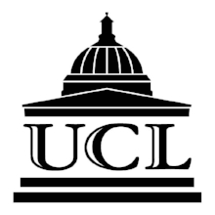

UCL is delighted to host Envision@UCL: a one-day free event, which includes lunch for young women of African & Caribbean heritage interested in learning more about university and future career options.

Envision@UCL will take place on Thursday 26th July 2018

Applications for Envision@UCL are open. To apply for a place, please complete the [**online form**](https://www.surveygizmo.eu/s3/90076502/Envision-UCL-26-07-18). **Applications close at 10AM on Friday 25th May 2018.**

In July 2018 UCL will be holding two Year 12 conferences, each investigating a theme that's relevant to how we see the world today.

These conferences are designed to give a taste of what studying at university is like, as well as to encourage deeper insight into an interesting and current topic. Students who attend will also:

* Receive helpful information about applying to competitive universities
* Meet current students and members of academic staff

**Tuesday 17th July - Beyond Medicine**

Have you ever pondered your own reflection and wondered: how does this body work? What about when something goes wrong - how can I fix it? UCL's Year 12 conference day on Tuesday 17th July will focus on the topic of *Beyond Medicine*..

**Thursday 19th July - Identity**

In ever-evolving social environments, can you be sure of who it is you think you are? Are you the same person you thought you were yesterday, or will be tomorrow? Perhaps it is the understanding of identity that changes, and we're all just trying to keep up. You're invited to examine these questions at UCL's Year 12 conference day on Thursday 19th July.

Applications for the July 2018 Gateways Conferences are now open. To apply, please complete [**this online form**](http://www.surveygizmo.eu/s3/90072968/July-Gateways-Application). The deadline for student applications to be completed is **11am on Monday 21 May**.

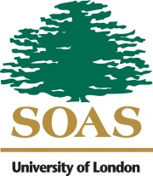Some of our students have won places at the SOAS summer school. There are a few more places available for the subjects below.

* Politics and International Relations - Tuesday 19th - Friday 22nd June
* History - Tuesday 10th - Friday 13th July
* Anthropology and Development Studies - Monday 16th - Thursday 19th July

**EXTENDED DEADLINE: 18/05/2018**

**Info and applications**: <https://www.soas.ac.uk/widening-participation/outreach/sixth-form/summer-schools/>

[](https://www.bing.com/images/search?view=detailV2&ccid=fgZ/k2LK&id=11DEF864D179E65F89A018CB5CECB27BA9DC4DDE&thid=OIP.fgZ_k2LKX_EeZVrwfB08iAHaIh&mediaurl=http://bloximages.chicago2.vip.townnews.com/dailysentinel.com/content/tncms/assets/v3/editorial/5/bf/5bf3c61c-4ad8-11e5-b3f0-13eb087adb59/55dbdf5959551.image.jpg&exph=460&expw=400&q=shout+out&simid=608019602979556108&selectedIndex=7)

**Leo Jeimovs –** for achieving the highest number of House Points in the 6th form and making a very positive contribution.

**Ravneet Kaur**- Jack Petchy Award

**Maria Williams** – Jack Petchy Award

**Disha Rana** – excellent presentation at the London Business School

**Ameerah Nehoor** – excellent presentation at the London Business School

**Krusha Gohel, Muhammad Tariq and Ajeendiny Vasanthakumar** – for winning places at the SOAS Summer School

**Fatima Asmat, Seema Bibi, Isha Kumar, Zoobia Munir, Anika Sharma, Simranjit Talwar** – for making such a great impression on the first day of their placements at Allenby Primary School

**Lady Ashong and Hana Hassan** - who presented to parents and students at our Year 8 My Future evening

**Zaynah Anwar, Afreen Afzal and Lady Ashong** – for gaining places on the Aspiring Professionals Programme Social Mobility Programme

**Zaynah Anwar, Lady Ashong, Shahzadi Koma, Shreya Markendrey and Eesha Raza** who have gained places on the Luninar course which they take place in Harrow School and will help them prepare for highly competitive courses

**Harshwarya Kaur, Head Girl and Kaloyan Haydutov, Head Boy**: for their expert chairing of the Executive Council Meeting with across school representatives.