6th Form News June 2018
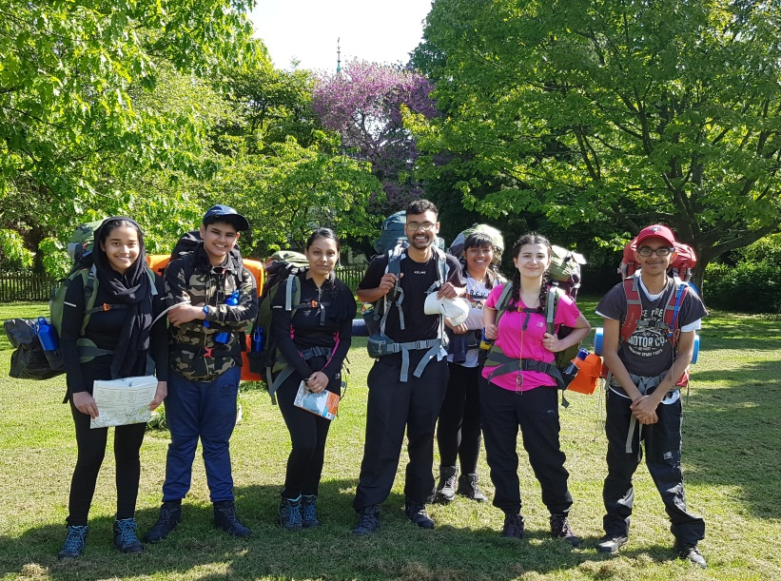
Study leave has started for Year 13 as A level examinations are well underway; we are delighted that so many Year 13s continue to come into school to prepare for their examinations. Our Btec students have all completed their courses with stunning outcomes. They are to be congratulated on their excellent results and university offers.

Meanwhile Year 12 students are developing themselves as very credible and deserving UCAS applicants. Thirteen of them have carried out a gruelling but rewarding DOE Silver expedition.
Above: Some of our brave Year 12s embarking on their Silver (DOE) Duke of Edinburgh Award

A number of Year 12 students have also signed up for the National Citizenship Service Challenge which will see them develop a range of skills and talents during the summer holidays. Other Year 12 students have taken up the in-school challenge of hosting a House competition in the English department: a ‘quotes quiz’ on the literature set texts, aimed at Year 11 students. Dr Porter is pleased with the attitude and commitment of students in The Medical Society, some of whom are looking to take part in the Cambridge Chemistry Challenge. It is also wonderful to see the number of focused Year 12 students who have achieved places in university summer schools. There are still opportunities to explore. (please see below). Keep striving Year 12 and you will reap the benefits!

Adnan Shinwari, Anjali Sagar, Daven Patel, Gaganpreet Kaur, Hassan Tariq, Kevin Varghese, Krusha Gohel, Maria Williams, Rahila Puthan Peediyakkal, Ramneek Kumar, Shreya Markendey, Vishal Barbara and Manraj Virdee - Our Silver DOE participants

Ravneet Kaur and Faheem Ashraf - Our ‘quotes quiz’ hosts

Fatima Asmat - Outstanding work in Health & Social Care

Hemayal Adnan; Naomi Ajim; Elfleda Akoto; Karam Altaweel; Ramneek Kumar; Anika Shama and Rahila Puthanpeediyakkal – Our recently appointed Headteacher’s ambassadors

Imaan Yazdan – gaining the highest number of achievement points

