Year 6/7 Summer Reading Activity 2023
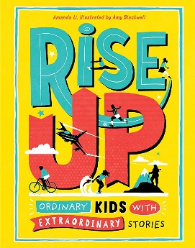
Rise Up by Amanda Li
At Dormers Wells High School, we aim for you to develop ‘a lifelong love of reading’. Reading for pleasure has become the most important indicator of future success for young people in school and in later life and is a key priority at our school.
As well as this, we want to promote the learning habits of our most successful Year 7 students, which we call our ‘Habits of Success for Strong Starts’ (see the back of this sheet).
To help you achieve a Strong Start with us in September, we are delighted to welcome you to our school through the gift of this inspirational book by Amanda Li, a collection of incredible true stories of young people from around the world who have overcome immense challenges.
Please complete the following activities as you will have a lesson on this when you join us in September:
- Read the whole book.
- Consider which personal stories you enjoyed reading the most and why.
- Complete the writing task below:
Write a review of one chapter of the book including:
- A brief summary of the young person’s achievements and the challenges they overcame.
- Why you found this person’s story inspirational.
- How the story relates to our Habits of Success for Strong Starts.
- What the story may inspire you to do in the future.

This should be one or two pages long. Please write on one side and ensure that it is presentable enough to be displayed (neat handwriting, proof-read, split into paragraphs and an attractive border and title). Any questions about this, please feel free to contact Mr Marker, Assistant Headteacher for Year 6/7 transition.

