Stressed Out!
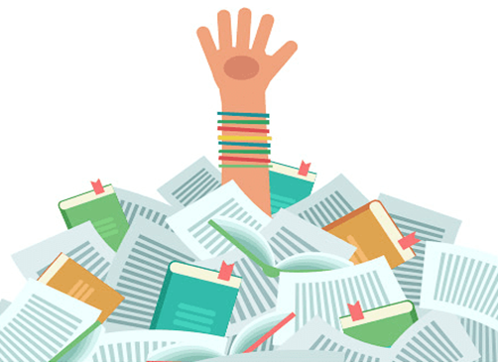
DOrmers Wells high school
Stress buster

ExAm StReSs Box

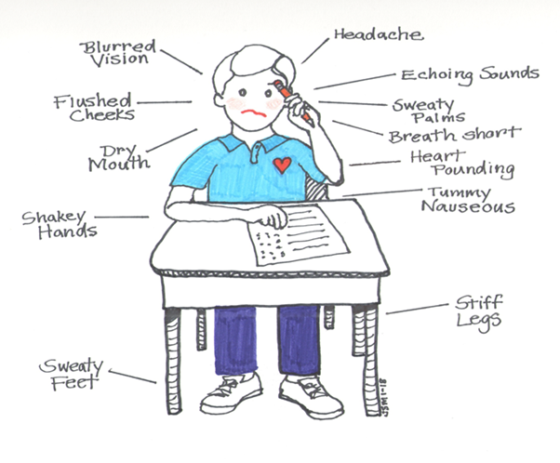

List here any other signs that you get when getting ready to sit an exam or sitting the exam.
---------------------------------------------------------------------------------------------------------------------------------------------------------------------------------------------------------------------------------------------------------------------------------------------------------------------------------------------------------------------------------------------------------------------------------------------------------------------------------------------------------------------------------------------------------------------------------------------------------------------------------------------------------------------------------------------------------------------------------------------------------------------------------------------------------------------------------------------------------

ExaM sTrEss EmOtIonS
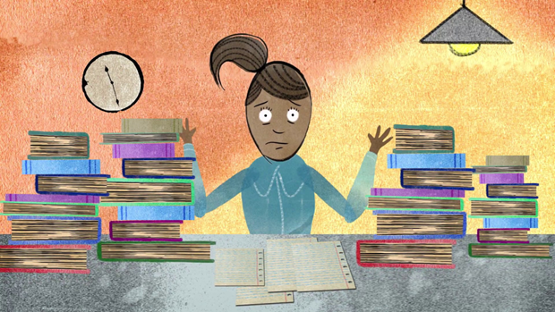
Tick the ones that fit you when stressed out.
Upset | Hypersensitivity | No sense of humour | Worry
Envy | Hopelessness | Anger | Loneliness
Low confidence | Distress | Numbness | Frustration
Low mood | Feeling out of control | Fear | anxiety
Nervousness | Shame | confusion | Sadness
Disappointment | Self doubt | Lack of resilience | Defensiveness
Self blame | Humiliation | Overwhelmed | Self loathing
unhappiness | worthless | Panic | insecurity

ExaM sTrEss bEhaViOuR  Which ones apply to you?  BEHAVIOUR | APPLIES TO ME  - Tick here
Be aggressive towards others.

Argue with friends and family.

Break off friendships or relationships.

Act defensively.

Become defiant.

Be disruptive.

Criticise yourself.

Cry.

Skip meals.

Binge or comfort eat.

Make yourself sick after eating.

Exercise excessively.

Drink alcohol or take drugs.

Self-harm.

Follow rituals and routines obsessively.

Look for reassurance from others.

Commit risk-taking behaviours.

Keep everything inside.

Avoid doing revision.

Wasting time doing other things – procrastinating.

Give up part way doing revision.

Avoid going to school.

Avoid going to certain lessons.

Avoid revision sessions at school.

Avoid exams.

Not finish the exam.

Avoid talking to people about exams.

Stop doing fun things.

Avoid making decisions.

Avoid leaving your bed, bedroom or house.

Sleep more/Sleep less.

Hide how you feel from others.

Study/ revise excessively.

Act in ways to please others.

WhAt CaN yOu Do?
ImPleMeNt ConStRuCtivE BeHaviouRs
You can change how you act by implementing constructive behaviours – these are behaviours that can help you to:
- Relax
- Feel better physically, mentally and emotionally
- Be more confident
- Study more effectively
- Cope with the pressure of exams
- Feel less stressed!
The constructive behaviours that we are going to look at are:
- Talking and asking for help
- Completing an exam stress diary
- Changing self-talk
- Relaxing and having fun!
- Problem solving
- Living healthily
- Dealing with the night before the exam
- Having a good exam day

Remember you do not need to use them all. Only the ones that you feel help you cope more successfully.

Talking and asking for help
The Hand of support
Sometimes when we feel overwhelmed we can feel lonely.
Think of 5 people that you could turn to for help.
Write the names of each person on the fingers of this hand.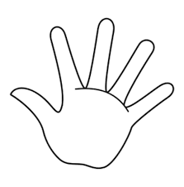
Don’t forget that you can talk to a professional, such as a counsellor, learning mentor or doctor about your worries.
You can also use the following helplines:
Childline.org.uk online or on the phone 08001111
Young Minds Crisis messenger -text your message to 85258

Sometimes it is difficult to know how to
Revising for my exams is making me feel really stressed out and I have been feeling …

start a conversation.
Try these ideas:
Have you got some time to listen to me, I’m finding things difficult right now?

I’m struggling to manage all my school work at the moment…

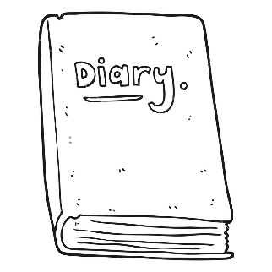
Completing an exam stress diary
Writing about your worries and stress can help you to challenge negative or unrealistic thoughts and identify ways to act differently to help you manage your stress or resolve a problem you may be facing.
You may also want to include 3 things that you are grateful for each day to help you also consider the positives.
An example of a diary

My negative thoughts and worries | Talk back and challenge (think about what a friend might say to you to support you)
I can’t get everything done, there is too much to do, I feel overwhelmed. | Ok so let’s see if I can make a list of what is to be done and break it down in to small steps. It’s going to be ok, I’ve got this!  If I am still struggling I can turn to my friend/teacher to help me out too.

Changing your self-talk
Your self-talk is how you talk about yourself, this can sometimes be very negative. Your exam and revision self-talk needs to be realistic and positive. Look at the box below to help you identify what your own self-talk is like and how you can change this.

Exam Stress Box

What words do you currently use when talking about your exam and revision related abilities?
…………………………………………………………………………………………………………………………………………………………………………………………………………………………………………………………………………
What effects does your self-talk have on you?
…………………………………………………………………………………………………………………………………………………………………………………………………………………………………………………………………………
How could you improve your self-talk?
…………………………………………………………………………………………………………………………………………………………………………………………………………………………………………………………………………

Relaxing and having fun!
Remember to build in time to have some fun!
You can use simple relaxation and deep breathing exercises to help you relax. Have a go at the following exercises and see what you think. It’s ok if these don’t feel right for you, they don’t suit everybody.

Breathing Exercises
Deep Breathing Exercise 1
Sit or lie down on your back. Focus on your breathing. Put one hand on your upper chest and one on your tummy. Gently breathe in and as you do so notice that your tummy rises under your hand. Slowly breathe out, notice how your tummy falls. Repeat the process, breathing in and out with a slow steady rhythm.

Deep Breathing Exercise 2
Lie on your back. Breathe in deeply and slowly, imagine that the breath is coming in through your feet, travelling up through your body and exiting through your head. Breathe in again, this time imagine that your breath is coming in through your head and out through the soles of your feet. Repeat this exercise several times and slowly.

Relaxation techniques
Relaxation Exercise 1
Close your eyes and imagine yourself somewhere peaceful, happy or enjoyable. Somewhere that makes you feel relaxed and happy. Focus on that image, start the build the detail and, for a short time, imagine that you are actually there. Breathe deeply and slowly as you do.

Relaxation Exercise 2
Focus on one muscle in your body at a time, slowly tighten and then relax the muscle.

If the above activities do not work for you, you could try other ways. Some young people use the following activities:
- Sport/ exercise
- Taking a hot bath
- Listening to music
- Watching Youtube or your favourite boxset
- Spending time with family or friends
- Reading
- Drawing
You could also use these activities as a reward when you have completed your revision plan!

Problem solving
Sometimes we can minimize our worries by identifying what the problem is.
For example: “I am really worried about my PPEs.”
The problem here is that you have to work towards achieving a specific grade.
Once you know what the problem make a list of the ways that you can solve the problem.
My worry is… | The problem is… | I can solve this problem by…

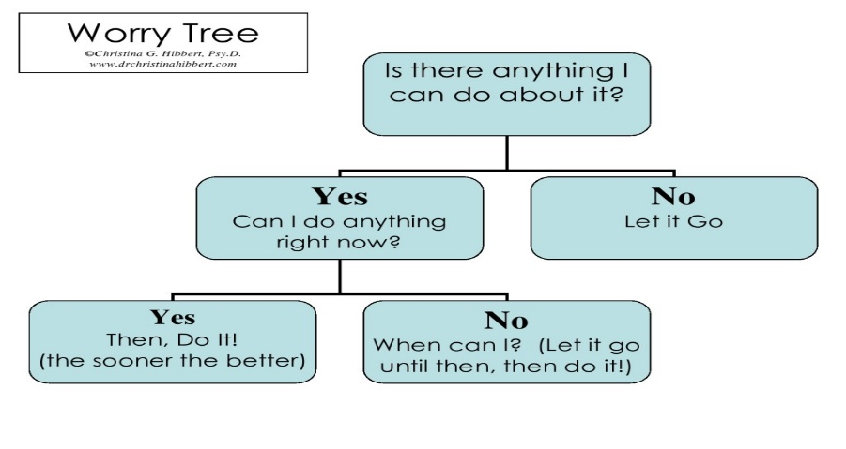
If you find it difficult to stop worrying, you could try to follow the Worry Tree flow diagram.

Living healthily
Make sure that you are getting enough sleep. Teenagers really need 9 hours of sleep per night!
Eat healthily and regularly each day. Don’t skip meals!
Drink plenty of water.
Take regular breaks from studying.
Get outside and take some exercise.

Dealing with the night before the exam
- You should have already revised thoroughly for your exam and only need to spend time using flash cards or memory maps to go over key ideas.
- You should remind yourself that you are ready for the exam and will do your best.
- Only speak to friends who will calm you down, exam stress is contagious!
- Eat a healthy evening meal.
- Go to bed at a reasonable time so that you are well rested before the exam.
- Pack your school bag with all the equipment you will need for your exam. Include a water bottle.
- Set your alarm clock.

Having a good exam day
- Wake up in plenty of time to eat breakfast and get to school.
- Check your bag for all the equipment you need as well as a water bottle and snacks for later.
- Meet up with friends along to way who are calming.
- If you find waiting in the long gallery stressful speak to your tutor to find an alternative.
- If you find you are becoming anxious take long restful breaths.
- DO NOT try to cram last minute.
- Remind yourself that you are prepared and will do your best.
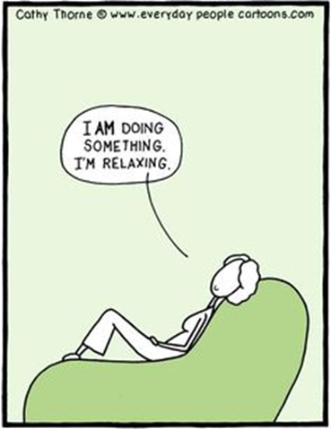

And remember, it is good to take time to relax!

Contact Us
Website: dwhs.co.uk

Written by S Cole - Cognitive Behaviour Therapist DWHS

